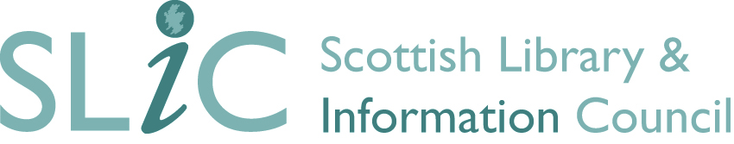

SLIC Service Excellence Award 2024

The SLIC Library Service Excellence Award 2024 recognises the outstanding contribution library teams throughout Scotland make to support their communities. The Award is open to all SLIC member libraries, with the winners receiving a trophy and cash prize.
All entries must highlight the work of library teams which demonstrate exceptional innovation and service design between June 2023 and June 2024.
An independent panel of judges will choose the winning service which will be announced at the SLIC Showcase and AGM on Friday 8th November 2024.

Organisation Details
Library Service
Lead Contact
Email address
Telephone
Title of submission
Activity

Please confirm this entry relates to activity which took place between 1st June 2023 and 1st June 2024.
Yes ☐
No ☐
Approval * Please confirm this submission has the approval of the Head of Service/Library Director
Yes ☐
No ☐
SLIC Showcase * We like to share best practice on the SLIC website. Please let us know if you are happy for this submission to be shared on our website. social media platforms and printed materials.
Yes ☐
No ☐
Can we contact you about additional opportunities to showcase and share your submission? For instance future face-to-face or online events, creation of case studies etc.
Yes ☐
No ☐

SLIC Service Excellence Award

Please tell us about your outstanding library service. What has the library service achieved over the last year? What was the impact and why was it exceptional?

- What did you do? How has the library service developed innovative and creative approaches to service delivery? (500 word limit)

- What drives your service delivery and planning? How have you engaged with users and how does your service support them? How have you engaged with staff at all levels and involved them in planning and delivery? (500 word limit)

- What difference did it make? How does the service contribute to the community it serves? (500 word limit)

4. What sets you apart? How has your library service gone above and beyond expectations? (500 word limit)

Supporting Information

Please submit any supporting information to support your entry along with your application. This can include promotional materials, media coverage or photographs. You may need to send these via a large file-sharing service.
Applications and any supporting information should be submitted to applications@scottishlibraries.org by 12 noon on Monday 2nd September, 2024. If you have any questions regarding your application, please contact us at info@scottishlibraries.org

