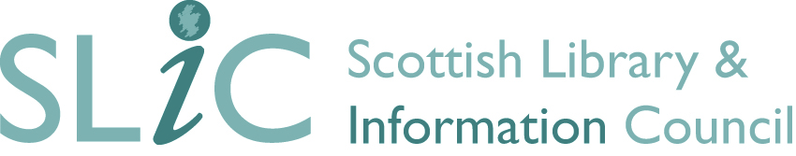

INNOVATION AND DEVELOPMENT FUND

GUIDANCE FOR APPLICANTS 2017/18
Please note: Applications may only be led by non-public library SLIC members.
This guidance is intended to assist SLIC members to apply for grants from the Innovation and Development Fund (IDF). It provides an introduction to the IDF award programme for 2016/17, outlining the key priorities, eligibility criteria and conditions of grant.

Section 1

1.1 Introduction
SLIC’s work across the Scottish library and information sector covers a wide range of activities including leadership support, advocacy, undertaking research, monitoring standards, facilitating partnerships, and supporting innovation. The Innovation and Development Fund aims to fund initiatives that support SLIC’s strategic priorities.

1.2 Priorities for funding
Our current priorities are:
- Advocacy
- Standards
- Innovation
- Partnerships
Funding will be considered for a range of activities including: research, impact analysis, service development, staff training, partnership working and the creation of new resources or services, case studies, preparation of good practice guides, or promotion of standards.

1.3 Eligibility for funding
Projects for which funding is sought must be of demonstrable value and have an impact on the development of library and information services in Scotland. SLIC encourages multidisciplinary and collaborative working but funding can be granted only to bodies in current membership of SLIC. However, members may apply for funding in partnership with a body not in membership.
Public library authorities eligible for Public Library Improvement Funding (PLIF) may not lead an application but are encouraged to participate in partnership bids with other organisations and sectors.

1.4 Timetable for applications
Applications will be accepted from Monday 13th November 2017 until 5pm on Friday 2nd February 2018. Bids will be assessed by a panel comprising SLIC Board members. Applicants will be notified of decisions in March 2018.
Please note up to two applications per library service can be submitted by an individual library service. However, an unlimited amount of collaborative bids is permitted.

1.5 Level of funding
The fund this year is set at circa £25,000. Applications will be accepted for any amount up to this level. Applicants may bid for projects lasting no longer than 2 years.

1.6 Offer of Award
When SLIC Board has approved an award, a formal offer will be made to the applicant, stating the amount of the award and any conditions attached to it.
Payment will be made in the first week of April 2018, so projects should commence soon after this time.
All projects must nominate a Project Leader who will be in overall control of the project and act as main contact with SLIC.
The Project Leader will be required to submit an interim report to the CEO of SLIC confirming satisfactory progress.
All expenditure listed must be accompanied by copy receipts. Where proof is not submitted, the item may be deducted from the claim.

1.7 Application procedure
The standard application form should be used. All applications should be submitted by the closing date of Friday 2nd February 2018 by 5pm. Late applications will not be considered.
Applications should be submitted electronically to applications@scottishlibraries.org
An online application form can also be submitted via the SLIC website at
http://scottishlibraries.org/innovation-and-development-fund/idf-funding-application/
Please ensure all applications are signed and dated. If submitting an online application, please email or send a signed copy to the SLIC office.

Section Two: SLIC Conditions of Grant

All successful applicants will be required to accept SLIC’s Conditions of Grant, as well as any specific conditions relating to their project, which will be communicated at the time the award offer is made.
2.1 All projects must be completed within the stated timescale and a final report provided. Any variation should be notified to SLIC as soon as possible, with an explanation for the delay. Severe slippage in the project timetable or failure to submit the final report may result in withdrawal of grant.
2.2 The award must not be used for any purpose other than that stated in the grant award notification letter, unless SLIC agrees to a variance in the project.
2.3 SLIC support must be acknowledged in any publicity or promotional material involved in the project. The SLIC logo can be supplied for this purpose.
2.4 Summary information on projects will be added to a SLIC project database to be made available on the SLIC website, and final reports will also be published on our website.
2.5 Recipients of awards may be invited to make a presentation at the annual SLIC Showcase in November.

Contact Details
For further information, please contact:
info@scottishlibraries.org
Scottish Library and Information Council
Suite 2.4, Second Floor
Turnberry House
175 West George Street
Glasgow
G2 2LB
Tel: 0141 202 2999

