3D Printing in Scottish Public Libraries
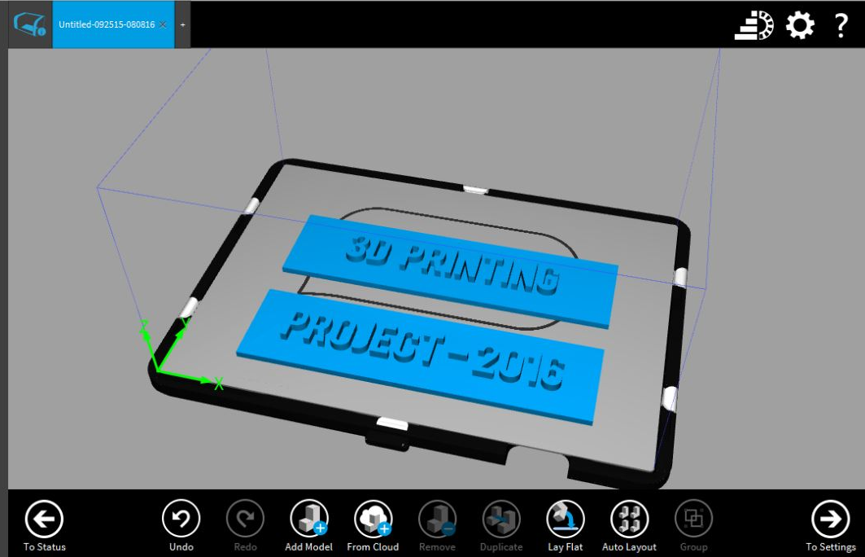
Final Report
August 2016

Iain Robertson
Digital Officer

Contents

Background |  | page 3
Visits to library services | East Lothian | page 4
 | Dundee | page 5
 | East Dunbartonshire | page 6
 | Stirling | page 7
 | North Lanarkshire | page 8
 | Edinburgh | page 8
Hardware selection and procurement |  | page 9
Project promotion |  | page 11
Branding |  | page 13
3D printing champions |  | page 13
Training |  | page 14
Yammer |  | page 16
Charging |  | page 17
Conclusion |  | page 17
Appendix 1 | 3D printing champion role profile | page 19
Appendix 2 | Participation agreement | page 20
Appendix 3 | Printing checklist | page 21

Background
Towards the end of 2015 the Scottish Library and Information Council (SLIC) made a successful bid for funding to the Scottish Government to introduce 3D printing in public libraries. This new technology had already been incorporated in a few library services where it was supporting a wide range of activities, and extending the digital offer to new audiences. The additional funding would provide the opportunity to expand and develop this growing area of interest and skills development to all Scottish library services, thereby increasing accessibility
The inclusion of 3D printing activities would help to support the recommendations of Ambition and Opportunity, A National Strategy for Public Libraries, in the following key areas:
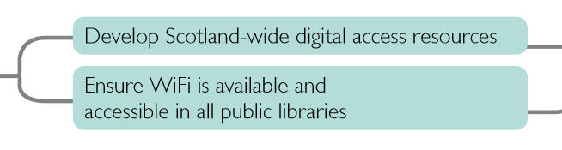
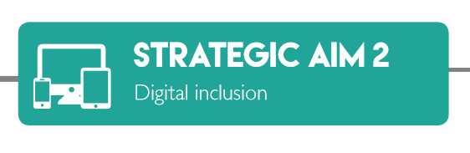
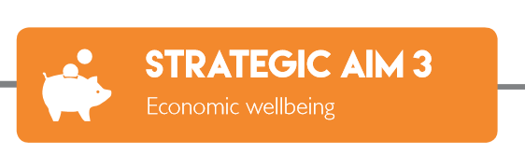
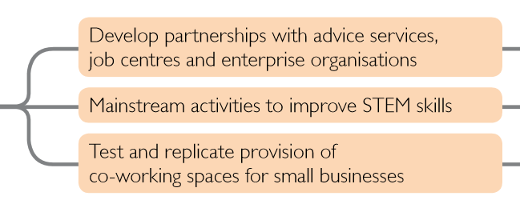
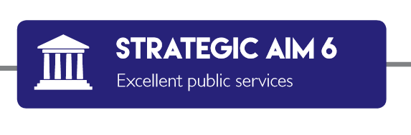
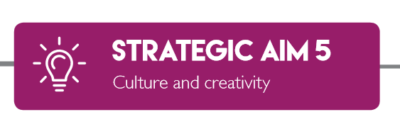

It was important to learn from the experiences of those library services already working with this technology, but also to recognise the potential for developing innovative and creative new approaches to using 3D printing to engage with current library users, and attract new ones.
Libraries have always embraced new technology and helped citizens in their communities to make the most of it. Since the beginning of the 21st century, many people have had their first experience of the Internet, and its associated activities, in public libraries. They were assisted by enthusiastic and supportive staff, who were themselves learning how to adapt to this new way of working and communicating. Ensuring WiFi is available in all public libraries (strategic aim 2) provides additional flexibility in how online services can be accessed, and delivered.
The knowledge, experience and infrastructure developed throughout this period demonstrate that public libraries are ideally equipped to continue to expand and reshape their digital offer.
I was seconded to SLIC for a period of 6 months to lead the roll-out of 3D printing, and to ensure that the library services would receive the best possible equipment, training, support, and opportunities to share best practice. This report will outline the progress of the project and highlight some of its milestones.

Visits to library services
Visits were undertaken to those library services where 3D printing had already been introduced. The intention of these visits was to learn about the approaches employed by the libraries when adding this new technology, and to discover any challenges that had to be overcome. In addition, valuable information regarding hardware, suppliers and support was gathered during this period.
East Lothian
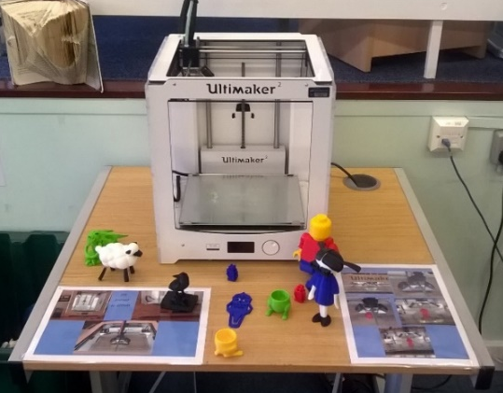
An invitation to the launch of the East Lothian 3D printer at Musselburgh Library was also my own first sight of the technology in action.
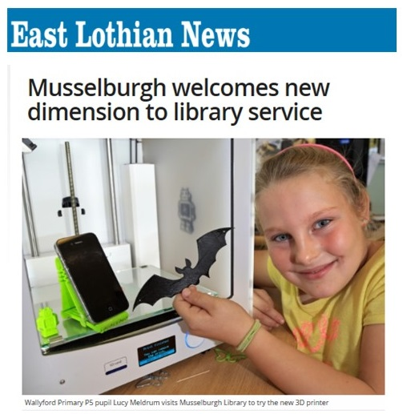
The event showcased their new Ultimaker 2 printer. The plan is to tour the printer around several community libraries before creating and developing learning programmes for school classes, as well as considering how the printer could be used to engage with local businesses.

It was encouraging to see that school children were attracted to the printer, and were interested in how it worked, offering suggestions about what could be printed. It was clear that the library was the only space in the community offering access to this technology.
The purchase of the printer and its associated items were funded through the Scottish Government’s Public Library Improvement Fund (PLIF), administered by SLIC.

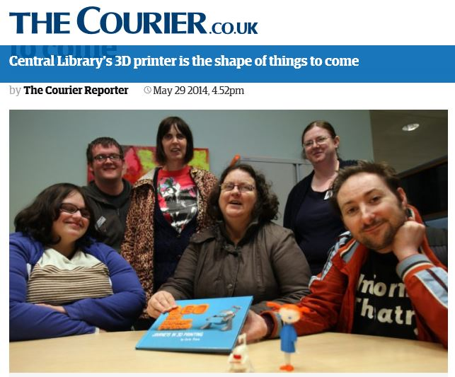
Dundee
In May 2014 Dundee Central Library was the first public library in the UK to incorporate 3D printing into their service. It enabled groups with additional support needs, who already used the library for storytelling, creative writing sessions and IT, to use the 3D printer to produce resources to assist the library and its users. This gave people in the group a real sense of achievement, and built confidence and self-esteem.

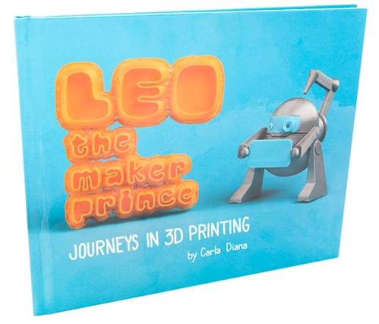
In one initiative characters from the book ‘Leo the maker prince’ were printed to complement children’s storytelling sessions, providing a more tactile engagement with the story.
This proved to be particularly valuable for children with visual impairment as they could touch and hold the characters as the story unfolded.

My visit to Dundee reinforced the value of engaged and enthusiastic staff. Their desire to explore the possibilities of the technology, and to maintain awareness of its continuing development, contributed to the success of the initiative.
Building on that success, the library is working in partnership with MAKLab to launch a makerspace in the Central Library this year. This will give users access to a range of digital making equipment as well as the support and knowledge required to use it. It will be a place for people to gather, discuss, develop and demonstrate ideas. A full range of workshops, training events, talks and other events will be delivered from this space, as well as outreach and community engagement events.

East Dunbartonshire
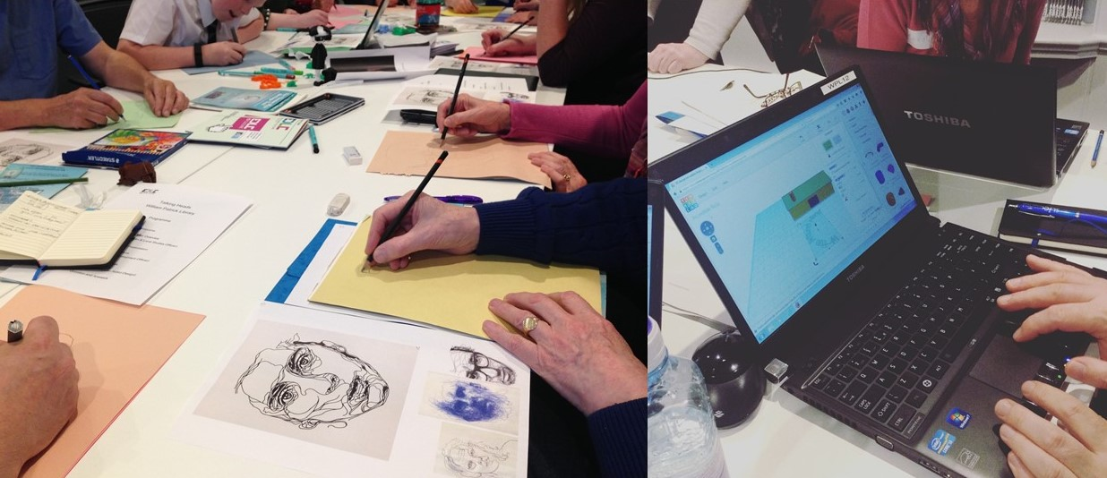
East Dunbartonshire Libraries launched their 3D printer in November 2015 with a series of ‘Talking Heads’ workshops based around the Thomas Muir Festival, marking the 250th anniversary of the birth of the ‘Father of Scottish Democracy’.
These multi-activity sessions featured presentations on local history and portraiture, as well as demonstrating the printer in action and showing finished printed models. These were produced either by scanning an object, such as a renowned bust of Thomas Muir, or by downloading ready-made digital designs from online 3D resources such as Thingiverse (http://www.thingiverse.com/). The participants were then given the opportunity to explore Computer Aided Design (CAD), using free online software (Tinkercad) to exercise their creative talents. The resultant designs were then 3D printed giving those attending a unique souvenir of the workshop.
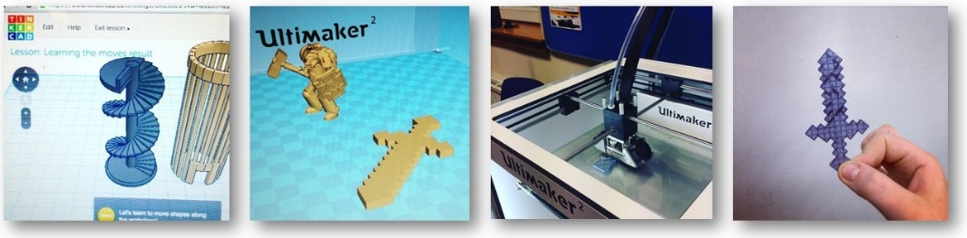

The 3D printing process can be fairly slow so models were picked up on subsequent visits to the library.
The free workshops attracted a wide range of participants, from school children to senior citizens, all offering positive feedback. It was particularly interesting to note that the school children had not seen a 3D printer ‘in real life’ prior to the sessions as the local schools did not have this technology.
East Dunbartonshire libraries have continued to be innovative in developing a range of activities based around their 3D printer and other digital equipment, delivering them to adults and children in their communities, including hard to reach rural locations.

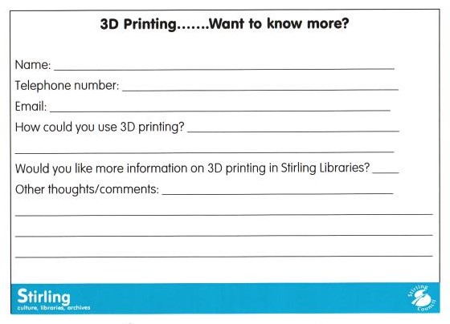
Stirling
Stirling Libraries included four 3D printers in their PLIF funded mobile makerspace. The printers were initially displayed in libraries to show them in operation, rather than as part of a planned event. This inspired some customers to suggest how they could be used for their own personal situations, and prompted the design of a form to gather more information, comments and ideas.
A retired clockmaker whose hobby was repairing old timepieces, studied the quality of the models produced and was confident that it was robust enough to print parts, now obsolete, to restore old clocks and watches. The next step will be to explore how best to reproduce these parts, either by scanning and modifying existing ones, or using design software to create them from scratch.
A woman who ran a gardening club wondered whether the printer could be used to produce a 3D model of the orchid they used as the club emblem. Nothing readymade could be found online so one of the library team has arranged to meet the woman when the flower is in bloom and use a 3D scanner to create a design file. Each member of the club will receive a brooch printed from that unique design. New ones can easily, and economically, be printed when required.
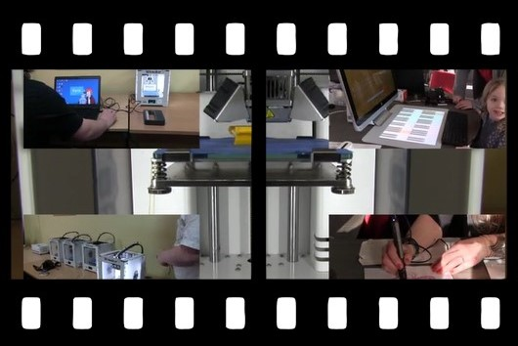
The library staff created a short film demonstrating their maker space equipment, including a 3D printer, in action. It can be viewed at:
https://scottishlibrarieswifi.org/2016/06/07/making-it-in-stirling-libraries/
North Lanarkshire
Inspired by the impact of the 3D printer in Dundee, and building on the digital engagement supported by the Technology Petting Zoo, North Lanarkshire libraries introduced a 3D printer in 2014.
It has been showcased in public libraries, schools and community facilities.
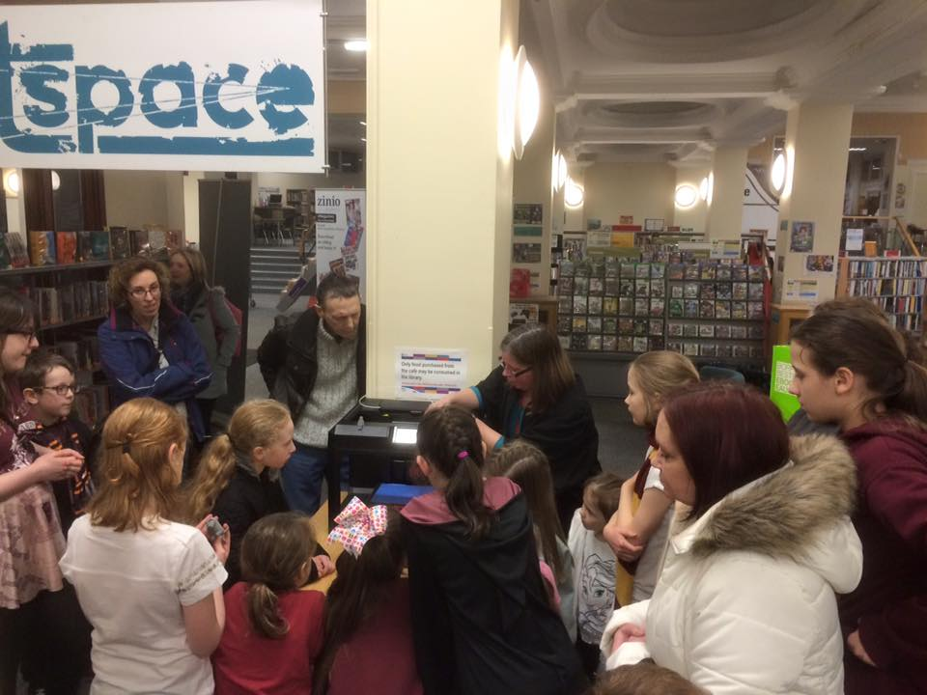

It also added to the magic during Harry Potter Book Night in Motherwell Library.

Opportunities to use 3D printing as a trigger for reskilling, in an area where traditional heavy industry is diminishing, are being considered.
Another consideration that was highlighted during the visit to North Lanarkshire was that of portability. To encourage maximum exposure to the printer, it must be easy to move between locations.

The SLIC Technology Petting Zoo was a collection of gadgets, including iPads, Android tablets, eReaders and Raspberry Pi kits, loaded with software and apps to demonstrate what they could do. Library staff and visitors enjoyed the chance to get hands-on with the devices.

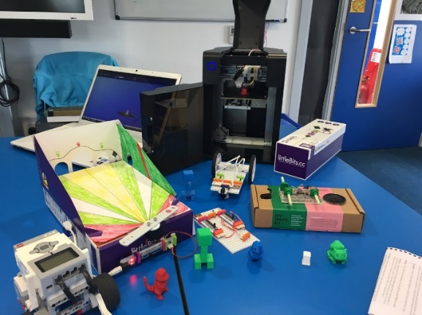
Edinburgh
Edinburgh libraries introduced 3D printing as just one element of their Carnegie Library Lab funded Digital Toyboxes. These are collections of equipment aimed at engaging children and young people in making activities. In addition to 3D printers they include robotics, electronics and music resources.
The three Toyboxes are based in Drumbrae Library Hub, but rotate around the city, enabling staff to deliver activities in other libraries, local schools and drop in events, promoting the resource and engaging a new audience of young people in library services.
Some of the activities that took place in Drumbrae Library Hub were featured on the BBC Make It Digital website, as part of the Build It Scotland initiative.
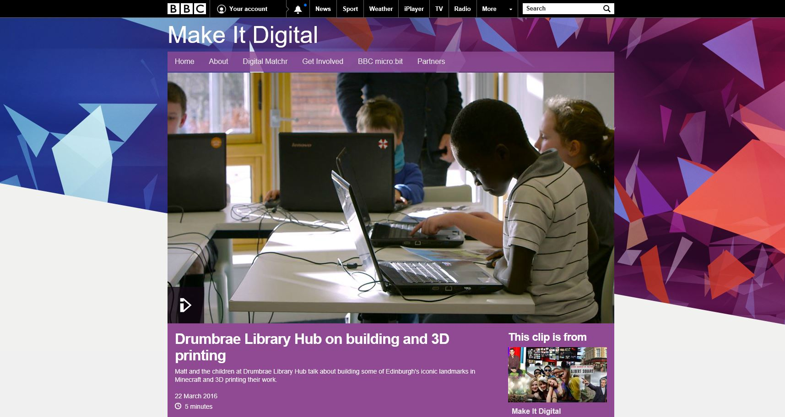
http://www.bbc.co.uk/programmes/p03np976
Hardware selection and procurement
The visits to the library services were invaluable when considering potential 3D printers, 3D scanners and suppliers for the project. In a huge market they helped to focus on hardware that was known to perform in a library environment, and significantly, highlighted manufacturers and suppliers whose support ranged from very good to poor.
It was agreed early in the process that in order to ensure the widest possible access to the technology, that every library service would be offered the opportunity to receive a package of equipment, training and support that would enable them to introduce 3D printing in their libraries. Those services who already had suitable equipment could substitute items in the package for other resources of a similar cost that would enhance their 3D printing offer.
The possibility that 32 printers and their associated items would be purchased, defined to some extent the unit cost. However, as mentioned earlier, portability was also uppermost when identifying suitable printers. Combining these factors with the experiences of those already working in this area resulted in a shortlist of potential devices.
It was recognised that a single procurement process would be more efficient and cost-effective than 32 separate processes.
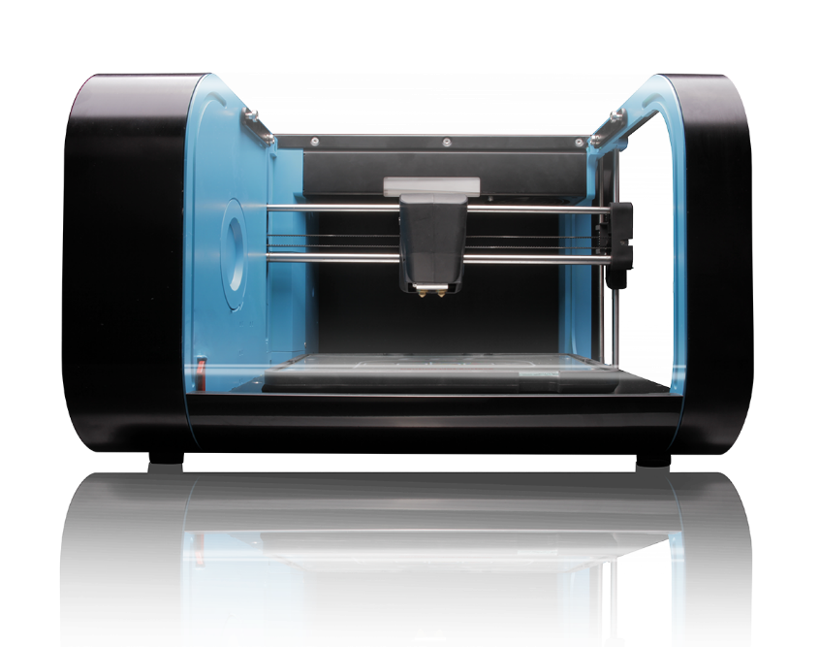
A list of suitable printers, scanners, consumables and other requirements were sent to potential suppliers who had already established good relationships with some of the library services. Quotations and comments were invited, prompting one company to recommend a 3D printer, the CEL Robox, which hadn’t previously been considered.

It included several features that warranted further investigation, such as an enclosed but visible print area, self-levelling heated print bed and the ability to pause and restart a print job.
It also indicated that the supplier who recommended it had shown an understanding of how the printers were to be used.

The printer was launched in 2014 to generally positive reviews, with a few minor criticisms that were addressed in subsequent updates, resulting in the 3D Hubs award for best plug ‘n’ play printer in 2016. It also offered a 2 year manufacturer’s warranty.
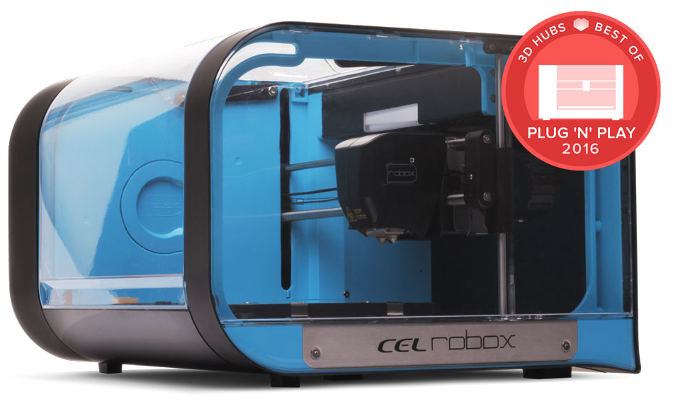

A CEL Robox printer was obtained for demonstration purposes, and presented the opportunity to arrange a ‘group test’ of shortlisted devices.
Hosted by Stirling libraries staff and attended by colleagues experienced in 3D printing from Angus, Dundee, East Dunbartonshire, Edinburgh (2 participants) and North Lanarkshire libraries, three printers were compared and rated across a range of criteria including portability, ease of use, safety, design, print quality etc. While not hugely scientific, the test did give a good ‘feel’ for the relative pluses and minuses of the printers, with the Robox coming out on top.
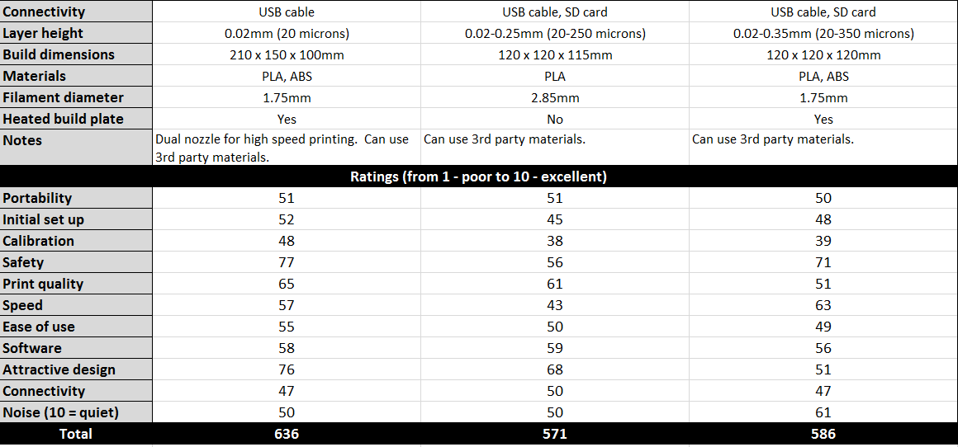

A fourth printer had been considered for the test but was discarded due to very negative experiences of manufacturer support.
As mentioned earlier, those library services who already had 3D printing equipment could opt for other 3D related items. Following this test, a couple who had intended doing so revised their decision as they felt that the Robox would complement their current offer.
A supplier was selected following a tender evaluation process.

Project promotion
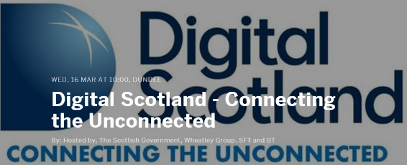
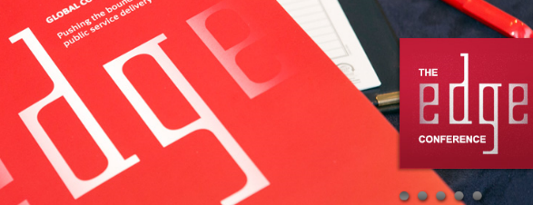
The project was promoted at the 2016 Edge and Connecting the Unconnected conferences, the latter resulting in further discussion with a Housing Association who could see potential commercial benefits in having access to this technology.
It was also introduced and promoted at a Digital Champions meeting in March 2016 where there was broad support and enthusiasm for the project.

The Digital Champions network includes representatives from all of Scotland’s 32 local authorities. The group is responsible for promoting digital participation through libraries.

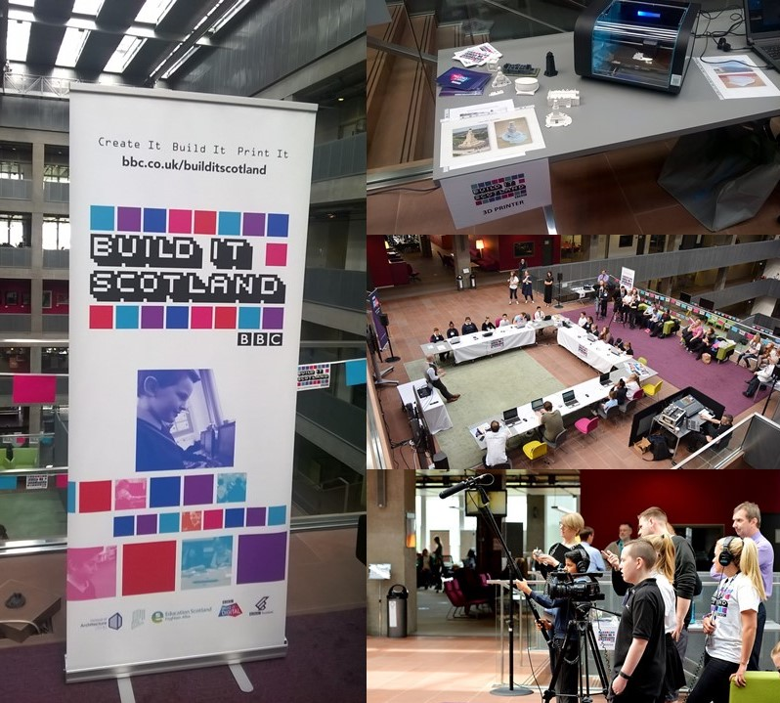

A visit to the BBC Build it Scotland pop up event in Glasgow also provided an opportunity to highlight the project. Children from a local primary school visited to find out about digital building, Virtual Reality and 3D printing. The children used Minecraft to create local landmarks in a virtual world.

Design files of buildings were created on Minecraft and Tinkercad (computer aided design software) and then 3D printed. This example is of the War Memorial on Law Hill in Dundee.
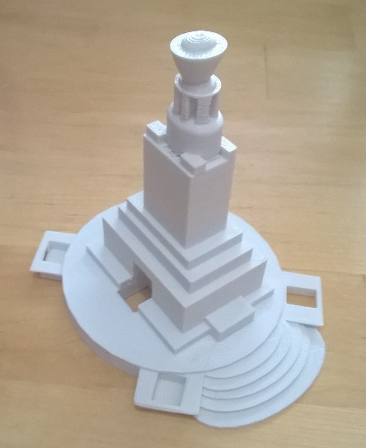
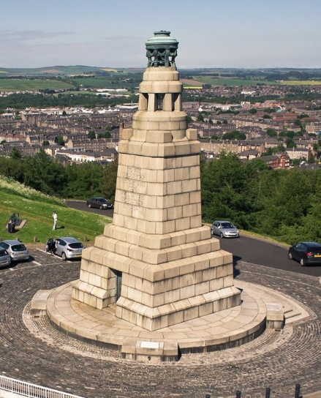

More informally the progress of the project has been sporadically recorded via an online blog at https://scottishlibrarieswifi.org/. This blog was created to report on some of the activities that developed as a result of the introduction of WiFi in Scottish libraries, but has widened to include other digital content.
Branding
Specifications for a project brand were produced, resulting in the creation of a logo and associated style guide.

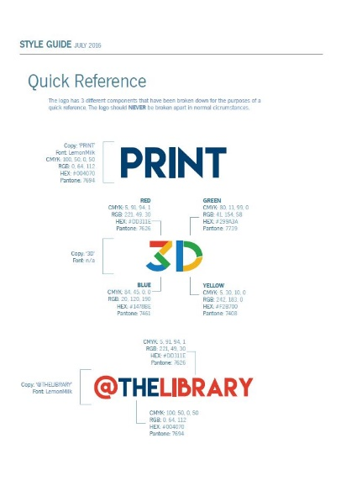
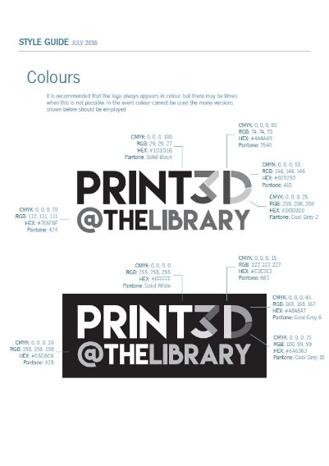

The logo should be used by all library services in any materials related to the 3D printing project.
3D printing champions
Each head of public library service was asked to nominate a 3D printing champion to implement, promote and support 3D printing, and its associated activities, within their library service. A role profile was created (appendix 1) to assist with this task. The heads of service were also invited at this time to formally agree to participate in the project through completion of a participation agreement form (appendix 2). All library services agreed to participate and 32 3D printing champions were nominated.
Training
One of the anticipated advantages of providing each library service with the same package of equipment was that training could be arranged that was printer specific. It was originally hoped that the 3D printing champions could potentially train on the printers ordered for them, but unfortunately their printers were not available in time.
The one-day training sessions were delivered by CREAT3D, the suppliers of the hardware. Four sessions were arranged over four consecutive days in July, at geographically suitable locations.
- Aberdeen 5 participants
- Glasgow session 1 5 participants
- Glasgow session 2 7 participants
- Edinburgh 10 participants
A final session took place in August for the remaining 3D printing champions.
- Edinburgh 5 participants
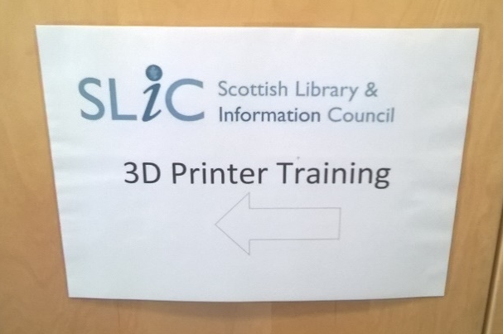
Having all 32 champions attend the training was hugely encouraging, particularly as it took place during a traditional holiday period, suggesting a real enthusiasm for the initiative across the library services.

The sessions covered the following topics:
- Introduction to 3D printing
- 3D printing basics (language, terminology, materials)
- Meet the Robox: hardware tutorial
- Meet the Robox: software tutorial
- The process checklist
- Sense scanner tutorial
- 3D printing and scanning practical
The participants were unanimously positive about the sessions, with even those who were experienced in using 3D printers gaining new insights about the processes. I attended all sessions and even during the last one still found the content to be interesting and engaging. It was also an opportunity to meet the 3D printing champions and reinforce some of the ambitions for the project.
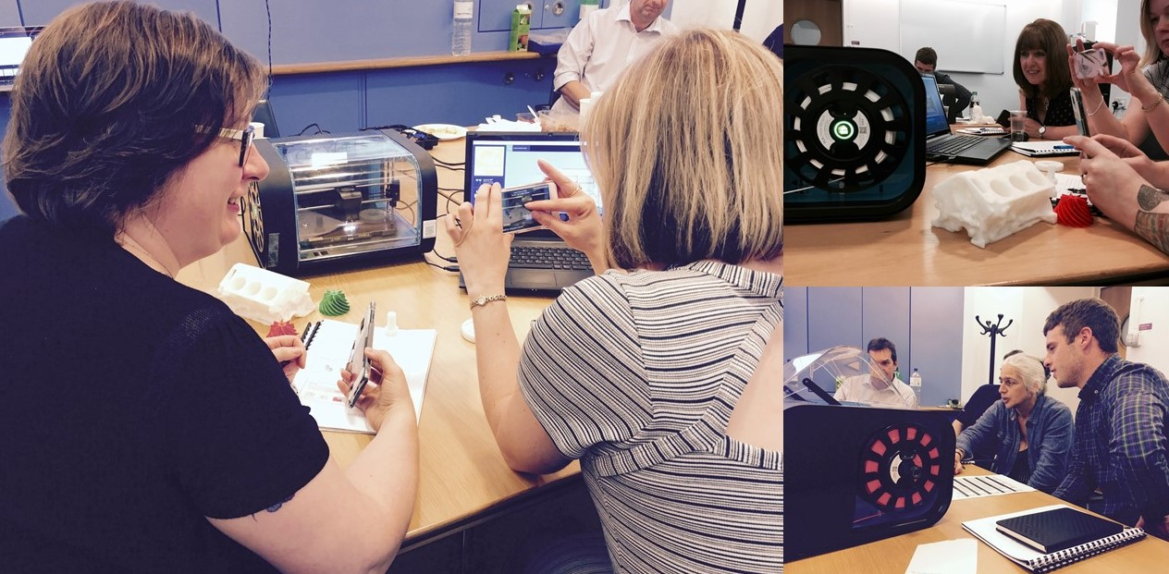
One of these ambitions was to develop an online platform where communication between the champions, and anyone else with an interest, could be maintained. I agreed to investigate suitable options.
Following some positive discussion about the ‘checklist’ element of the training notes, I also agreed to produce a single sheet version that could be used when preparing to print an item (appendix 3).
Some post training feedback received via email included:

It was a cracking day and I feel like we all learned a lot.
It was possibly the best training session I have ever attended.
The training was really enjoyable and I learned so much that I can cascade to my team.
The session passed in a flash! Just can’t wait to get going now.

Yammer
Several online applications were explored with the aim of identifying a suitable platform for maintaining and enhancing communication between the 3D printing champions, and with other relevant parties.
Yammer was chosen for several reasons including the following:
- It enables communication via ‘conversations’ that can be tagged by topic.
- Photos, videos, documentation, and .STL format files can be uploaded and shared.
- As a ‘freemium’ service, Yammer can be used at no cost, however additional functionality or features may be purchased if required.
- SLIC previously set up a Yammer account to enable communication with library staff engaged on the Training in New Technologies (TNT) programme, and some library services also used it for internal projects. Therefore there was already familiarity with the layout and functionality. The 3D printing champion’s platform is an external group to the SLIC one, meaning that existing users can participate in the group without the need to create new accounts.

Training in New Technologies (TNT) is an online training programme that aims to improve the practical knowledge and skills of library staff in using new technology devices and web services, including mobiles, tablets, mp3 players, social networks and mobile apps.

It is anticipated that this Yammer group will provide a space where 3D printing champions can share informal support, ideas for activities, design files, expertise and promotional materials. Two or three volunteers will be sought from the champions to act as group administrators following the completion of my secondment. It will be their responsibility to approve new member requests as well as monitor the longer-term suitability of the Yammer platform.

Charging
There has been some discussion about the possibility of charging for use of the 3D printing service. The funding to support the project was provided by the Scottish Government Digital Directorate, via the Digital Participation team with a real focus on ensuring access for everyone. To support this inclusion it is preferred that no charges be made for 3D printing during the funding period.
However it is recognised that there will be an ongoing cost associated with the printers, at a time where budgets are under pressure and there is a drive for income generation, therefore beyond the funded period, charging will be at the discretion of individual services.
The following points though, should be considered:
- 3D printing is often more of an art than a science. Staff will need time to familiarise themselves with the equipment and processes, to ensure that the best possible results are achieved. Offering a chargeable service before this level of expertise is attained may cause a negative perception of the offer.
- It may be worthwhile to investigate the possibility of adopting a model which retains a basic level of free 3D printing alongside an enhanced offer which may incur a cost.
- Perhaps the activities and events that are created around the 3D printer will have a positive impact on income generation via indirect spending, for example, through increased footfall.

Conclusion
An exciting part of my early visits to those library services which were pioneering the use of 3D printers was the sense of creativity and innovation. They largely had to develop new activities as there were few existing ones to copy or adapt.
The section highlighting those visits demonstrates, I believe, the diversity of events and activities that the freedom from a prescriptive programme inspired. Library services should continue to explore inventive ways of incorporating the technology, reflecting its cutting edge character, and targeting those in their communities who would benefit from engagement with it.
Publicly displaying the printers and producing ready-made models will undoubtedly attract people to the technology, but library services should also strive to develop activities that will empower and teach people to use it. The problem-solving that often takes place prior to printing may be as valuable as the end product. Libraries must also anticipate the future demand for this type of service, and be prepared to invest in its development, or signpost users to alternative providers such as Fab Labs.
A slight regret is that the printers were not delivered sooner, possibly enabling earlier assessment of their impact. However I believe that the time taken to select suitable hardware and a sympathetic supplier will prove to be beneficial as the project moves forward. It is important that impact is evaluated but perhaps this could be achieved when the 3D printing champions have gained confidence in the technology and had the opportunity to explore how best to promote it in their services.
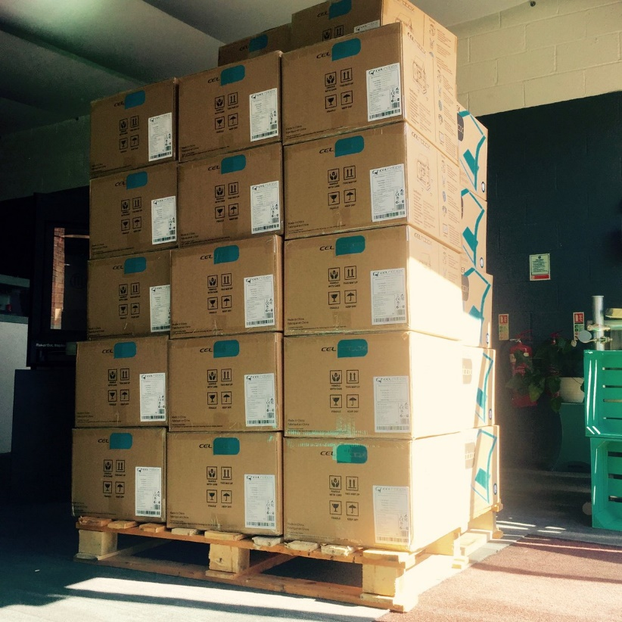

Here are the 32 printers on Friday 26th August 2016 awaiting distribution.
It is exciting and fascinating to imagine the impact they might have on people across Scotland.

Appendix 1

SLIC 3D Printing Champion: Role Profile

Role Purpose:
To implement, promote and support 3D printing, and its associated activities, within the library service.

Key Tasks:
- To cascade training and share information with relevant colleagues and other users.
- To engage with the 3D Printing Champions network to share and promote best practice across library services.
- To create learning sessions, activities and events, inspired by the 3D printer.
- To develop good practice case studies to promote 3D printing activities across library services and to external partners.

Experience and Skills:
- Enthusiasm for digital participation activities in public libraries.
- Excellent communication and presentation skills.
- Experience of, or interest in, some or all of the following topics
  - 3D printing
  - Computer Aided Design
  - Minecraft
  - Coding
  - Makerspaces
- Proficient in hardware and software problem solving.

Staff Commitment:
- Attendance at full day training course in Summer 2016.
- 3D Printing Champions may occasionally be asked to take part in other events and activities to promote the service.

Head of Service Commitment:
- Nominate appropriate staff member.
- Approve time out to attend training or other activities.
- Facilitate CPD in this area.

Role of SLIC:
- SLIC will coordinate initial training events and select suitable hardware.
- SLIC will promote the impact of the 3D printing events and activities to Scottish Government and other stakeholders, highlighting the contribution of the 3D Printing Champions.

Appendix 2

3D Printing Project – Participation Agreement
Library Service

I wish to participate in the 3D Printing Project and agree to,
- Nominate a 3D printing champion and support them in carrying out the tasks identified in the role profile.
- Ensure that the following items are used to establish and develop a 3D printing offer within my library service.
  - 1 x 3D printer (approx value £900).
  - 1 x handheld 3D scanner (approx value £150).
  - 2 x rolls of filament.
  - 1 x full day training, delivered by the hardware provider
(If the library service already has suitable 3D printing equipment and would prefer to request alternative items of similar cost that may further develop the 3D offer, please reply with details)
- Ensure that project branding and marketing materials are used effectively.
- Send a project report to SLIC by 5pm on 31st January 2017, highlighting the impact of 3D printing and its associated activities. A template will be issued in advance of this deadline.
I would be grateful if you could confirm your agreement by completing the details below and returning a copy to me by Friday 10th June 2016. Electronic signatures can be accepted.

Name of 3D Printing Champion
Email address for 3D Printing Champion
Head of Library Service
Head of Library Service Signature

Appendix 3
Checklist

Complete the following steps to prepare for printing. Ensure that all aspects are discussed with the customer, and tick the boxes as required.

1. Does the customer have an STL design file?

Yes

No |  | Advise the customer that 3D design in .STL format is required. Direct them to online 3D design tools, e.g. Tinkercad, SketchUp, AutoDesk.

2. Is the STL design file error-free in NetFabb Basic?

Yes

No |  | Advise the customer that the 3D design file must be ‘watertight’ and error-free. They can download NetFabb Basic themselves to check their STL files for errors.

3. Is the design printable?

Yes

No |  | Advise customer of the limitations of the FDM 3D printing process.
Maybe |  | Printing can be attempted, but advise customer that results may not be as desired.

4. Will the part require support material?

Yes |  | Advise customer that support material will require removal, leading to scarring on the supported surface. Orientate to minimise support material. Discuss ‘important surfaces’ with customer.
No

5. Does the part need to be scaled?

Yes |  | Agree print size with customer and scale part in AutoMaker.
 |  | Width (mm) |  | Height (mm) |  | Depth (mm)
No |  | Confirm with customer that part is correct size and therefore doesn’t require scaling.

6. Is surface finish important?

Yes |  | Advise customer that thinner layers = longer print time – use AutoMaker to demonstrate. Show examples of different layer heights.
No |  | Choose ‘Normal’ or ‘Draft’ print settings (tick box below)
 |  | Normal |  | Draft

7. Does the part need to be strong?

Yes |  | Increase fill density percentage e.g. 40-70%, or tick this box to indicate that colorFabb nGen material (if available) is to be used.
No |  | Choose standard fill density percentage (20%).

8. Will the print require a brim?

Yes |  | If the part has large surface area, consider using a brim to increase platform adhesion. Advise customer that brim will need to be removed.
No

9. Does the print require a raft?

Yes |  | If the part requires a lot of support material, lacks stability or has a small surface area in contact with the print bed, consider using a raft. Advise customer that raft will need to be removed after printing, and may scar the bottom surface of the part.
No

10. How long will it take to print?

Enter the estimated print time once the settings have been processed in AutoMaker.

11. Use this space to record any other comments or considerations.

